**Project Design Phase-II**

**Technology Stack (Architecture & Stack)**

|  |  |
| --- | --- |
| Date | 03 October 2023 |
| Team ID | 62068211D555C508F8E4542C3732872A |
| Project Name | Project - xxx |
| Maximum Marks | 4 Marks |

**Ab Architecture:**

The Deliverable shall include the architectural diagram as below and the information as per the table1 & table 2 **Example: Order processing during pandemics for offline mode**

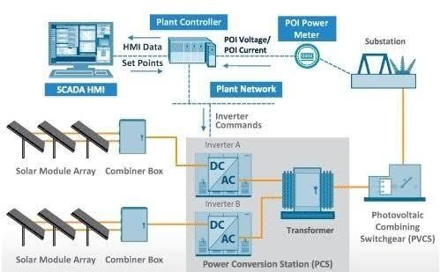

**Guidelines**

Data Collection:

Integrate weather APIs for real-time and historical weather data.

Collect past solar generation data from the solar panels at the specific location. Data Preprocessing:

Clean and preprocess data, handling missing values and outliers.

Normalize or scale features to ensure consistent input for the forecasting model. Feature Engineering:

Extract relevant features such as time of day, day of the week, and seasonal patterns. Incorporate shading patterns, if applicable, to improve accuracy. Model Selection:

Choose appropriate forecasting models like LSTM (Long Short-Term Memory) or ARIMA (AutoRegressive Integrated Moving Average). Evaluate ensemble methods for enhanced accuracy.

Training and Testing:

Split the dataset into training and testing sets.

Train the model on historical data and validate its performance on a separate test set. Real-time Integration:

Implement a mechanism for real-time data updates from weather APIs and solar panels. Ensure seamless integration with the forecasting model to adapt to changing conditions. Scalability and Flexibility:

Design the architecture to handle increased data volumes as the project scales.

Consider cloud-based solutions for scalability and flexibility.

Monitoring and Maintenance:

Implement monitoring tools to track model performance over time.

Schedule regular updates and retraining based on new data for model maintenance. User Interface (Optional):

Develop a user interface for stakeholders to visualize forecasted solar generation. Include relevant metrics and insights for better decision-making. Documentation:

Document the entire architecture, including data sources, preprocessing steps, and model details.

**Table-1 : Components & Technologies:**

|  |  |  |
| --- | --- | --- |
| **Component** | **Technology** | **Justification** |
| **Data Acquisition** | **Weather data APIs, Satellite imagery APIs** | **Access real-time and historical weather data from various sources** |
| **Data Preprocessing** | **Python, Pandas, Data cleaning libraries** | **Clean, prepare, and transform weather data for analysis** |
| **Feature Engineering** | **Meteorological expertise, Python, scikitlearn** | **Extract relevant features from weather data that influence solar panel power generation** |
| **Machine Learning** | **TensorFlow, Keras, scikit-learn** | **Train and optimize machine learning models for solar panel power generation forecasting** |
| **Data Storage** | **Train and optimize machine learning models for solar panel power generation forecasting** | **Store large volumes of weather data, forecasts, and model metadata** |

**Application Characteristics:**

